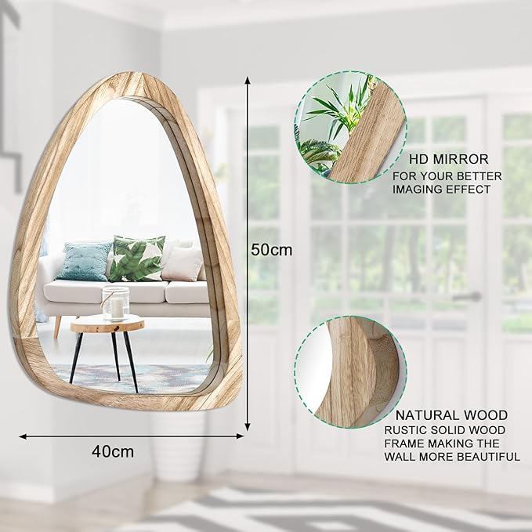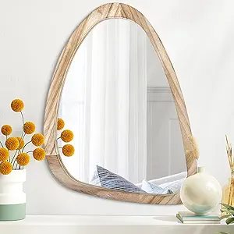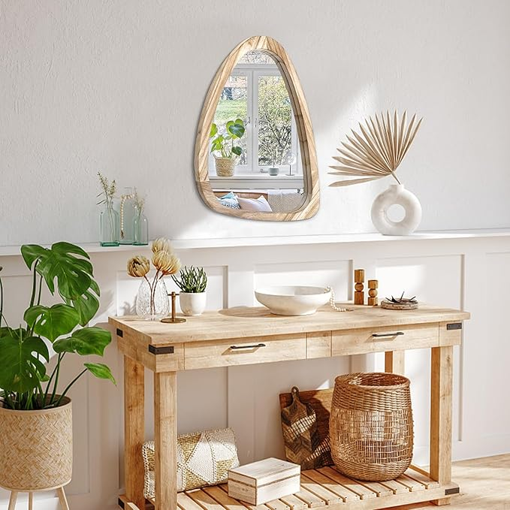

Asymmetrical Decorative Natural Mirror for Wall Large 20"x16" Modern Oval Wooden Framed Wall Mirror Unique Shape Wall Mounted Vanity Artistic Wavy Mirror for Living Room Bedroom Bathroom Entryway

PRODUCT DESCRIPTION

|  |  |
| --- | --- |
| **Brand :** | Lusso |
| **Room Type :** | Vanity Living Room Bathroom Bedroom Entryway Hallway |
| **Shape :** | Oval |
| **Product : Dimensions** | 20"L x 16"W |
| **Frame : Material** | Wood |

**About this item**

* 【Chic Asymmetrical Design】: The asymmetrical irregular unique shaped design mirror makes your bathroom, living room, room is both simple and classy, which especially attracts your eyes. Ideal for decorative bathroom makeup mirror to make the space more brighter and spacious.
* 【Clear & NO Distortion】: HD environmentally friendly copper-free silver mirror design, no amplification, no deformation, no dizziness, higher image clarity, better imaging effect. Wall decorative mirror is a powerful assistant for your exquisite make-up, dressing, shaving and organizing dress.
* 【Easy To Install】:20"L x 16"W. Can be hung horizontally or vertically.The irregular artistic mirror features sawtooth hangers on the back and hardware included in the package to ensure the mirror stay more securely and sturdily against the wall. Very easy to install.
* 【Multi-scene use】:Wall mounted home decor living room entryway framed irregular mordern mirror, people can choose the perfect size for they needs.This asymmetrical modern oval wooden framed mirror is a wonderful addition to your bathroom、vanity、bedroom、living room、dining room、salon checkroom!
* 【What You Get】1 PCS Asymmetrical Wood Frame Mordern Wall Mirror + We strive to bring you high quality products, and Worry-Free Post-Sale Service and Friendly Customer Service !! If for any reason you aren’t satisfied, simply reach out to us so we can make things better. -- Enjoy the Beautiful Addition For Your Home.